Assignment 5: Auto-Tagging EC2 Instances on Launch Using AWS Lambda and Boto3
Objective: Learn to automate the tagging of EC2 instances as soon as they are launched, ensuring better resource tracking and management.
Task: Automatically tag any newly launched EC2 instance with the current date and a custom tag.
Instructions:
1. EC2 Setup:
- Ensure you have the capability to launch EC2 instances.
2. Lambda IAM Role:
- In the IAM dashboard, create a new role for Lambda.
- Attach the `AmazonEC2FullAccess` policy to this role.

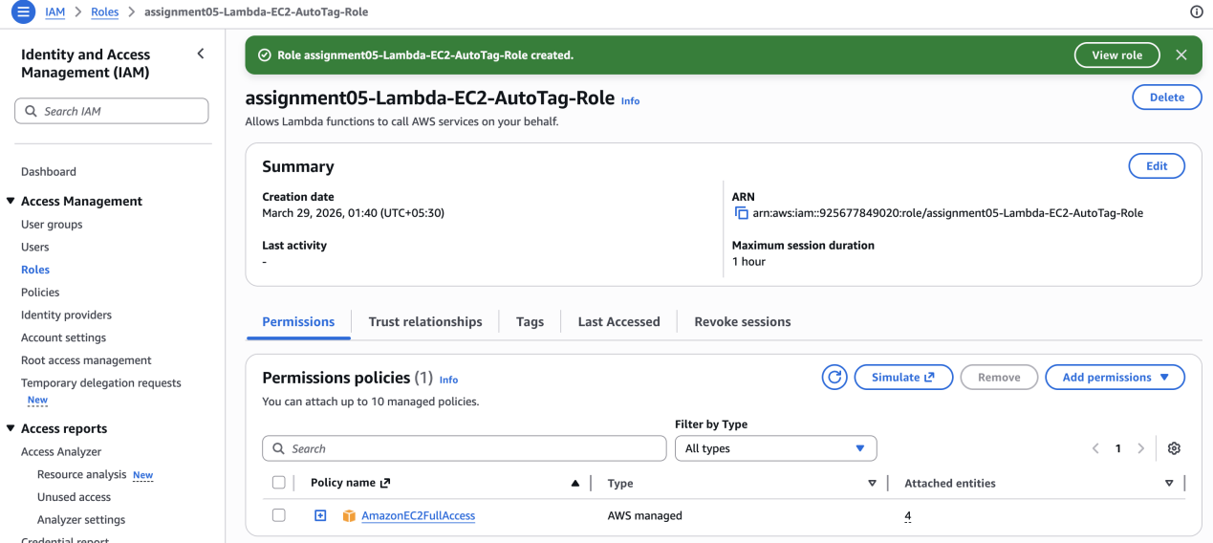

3. Lambda Function:
- Navigate to the Lambda dashboard and create a new function.
- Choose Python 3.x as the runtime.
- Assign the IAM role created in the previous step.
- Write the Boto3 Python script to:
1. Initialize a boto3 EC2 client.
2. Retrieve the instance ID from the event.
3. Tag the new instance with the current date and another tag of your choice.
4. Print a confirmation message for logging purposes.
4. CloudWatch Events:
- Set up a CloudWatch Event Rule to trigger the EC2 instance launch event.
- Attach the Lambda function as the target.

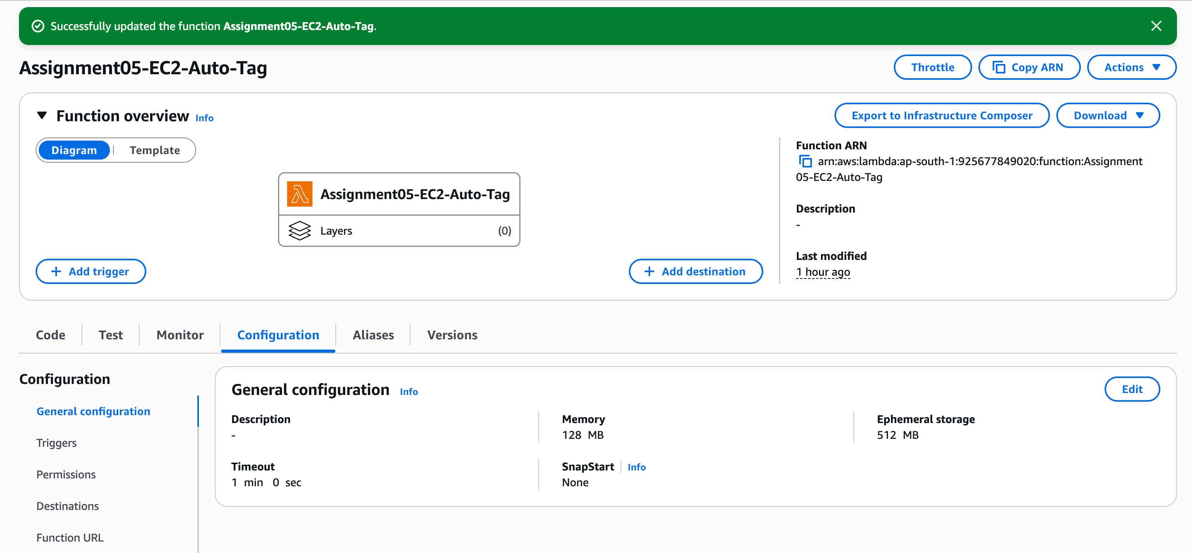
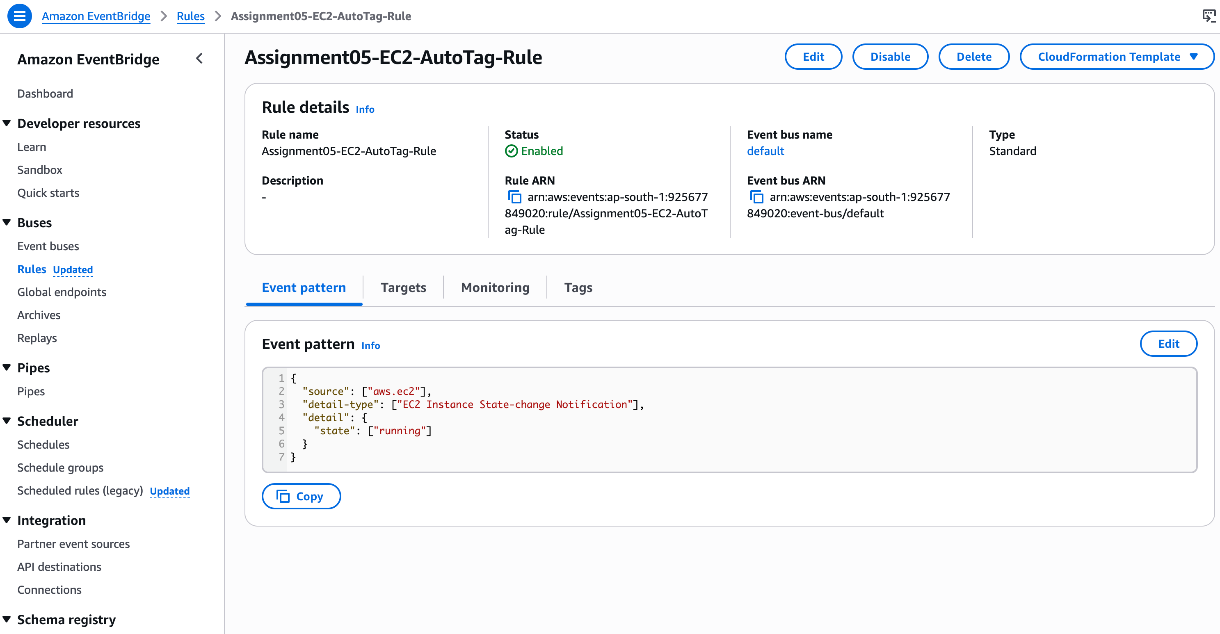

import boto3
from datetime import datetime

ec2 = boto3.client('ec2')

def lambda_handler(event, context):

print("Event received:", event)

# Get Instance ID from EventBridge event
instance_id = event['detail']['instance-id']

# Current date
current_date = datetime.utcnow().strftime('%Y-%m-%d')

# Tags to apply
tags = [
{
'Key': 'LaunchDate',
'Value': current_date
},
{
'Key': 'Owner',
'Value': 'AutoTagged'
}
]

# Apply tags
ec2.create_tags(
Resources=[instance_id],
Tags=tags
)

print(f"Successfully tagged instance {instance_id}")

return {
'statusCode': 200,
'body': f"Tagged {instance_id}"
}

5. Testing:
- Launch a new EC2 instance.
- After a short delay, confirm that the instance is automatically tagged as specified.

